CSC500 Module 4: Portfolio Milestone

Online Shopping Cart with Input Validation

Source Code
""""
Milestone 1
Online Shopping Cart
Author: Shadab
"""
# Python code to calculate the total cost of all items in the Shopping Cart
# user provides Inputs at Runtime and also validations for inputs
class ItemToPurchase:
# Constructor to Initialize Item Details
def __init__(self, name = "none", price = 0.0, quantity = 0):
self.itemName = name
self.itemPrice = price
self.itemQuantity = quantity
# Method to Calculate and Display the Total Cost of the Item
def print_item_cost(self):
total_item_cost = self.itemPrice * self.itemQuantity
print(f"\n{self.itemName} {self.itemQuantity} @ ${self.itemPrice} = ${total_item_cost}")
# Function to Validate the Purchased Item Name
def get_valid_item_name(existing_items):
while True:
item_name = input("Enter Purchased Item Name: \n").strip()
# Validation of Empty Input
if item_name == "":
print("Item Name cannot be Blank!! Please Enter Purchased Item Name.\n")
# Validation to prevent item names with only Numericals
elif item_name.isnumeric():
print("Warning!! Item Name cannot contain only Numerical Characters.\n")
# Validation to check for Special Characters
elif not item_name.replace(" ", "").isalnum():
print("Warning!! Item Name cannot contain Special Characters.\n")
# Validation to check if the Item Name already Exists
elif item_name.lower() in existing_items:
print("Warning!! Item name already exists.\n")
else:
existing_items.add(item_name.lower())
return item_name
# Function to Validate the Purchased Item Quantity
def get_valid_item_quantity():
while True:
item_quantity = input("Enter Purchased Item Quantity: \n").strip()
# Validation of Empty Input
if item_quantity == "":
print("Item Quantity cannot be Blank!! Please Enter Purchased Item Quantity.\n")
continue
try:
# Converting Quantity to Integer
quantity = int(item_quantity)
# Validation to check if Quantity is Negative or Zero
if quantity <= 0:
print("Warning!! Purchased Item Quantity should be greater than 0.\n")
# Validation to limit Quantity
elif quantity > 10000:
print("Warning!! Purchased Item Quantity is too high.\n")
else:
return quantity
except ValueError:
print("Warning!! Purchased Item Quantity must be an integer.\n")
# Function to Validate the Purchased Item Price
def get_valid_item_price():
while True:
item_price = input("Enter Purchased Item Price: \n").strip()
# Validation of Empty Input
if item_price == "":
print("Item Price cannot be Blank!! Please Enter Purchased Item Price.\n")
continue
try:
# Converting Price to Float
price = float(item_price)
# Validation to check if Price is Negative or Zero
if price <= 0:
print("Warning!! Purchased Item Price should be greater than 0.\n")
else:
return round(price, 2)
except ValueError:
print("Warning!! Purchased Item Price must be an integer.\n")
# Function to Validate the Number of Items Purchased
def get_number_of_items():
while True:
# Prompt User for Number of Items Purchased
number_of_items = input("Enter Number of Items Purchased:\n").strip()
# Validation of Empty Input
if number_of_items == "":
print("Number of Items cannot be Blank!! Please Enter Number of Items Purchased.\n")
continue
try:
number_of_items = int(number_of_items)
# Validation to check if Number of items is Negative or Zero
if number_of_items <= 0:
print("Warning!! Purchased Number of Items should be greater than 0.\n")
# Validation to limit Number of Items
elif number_of_items > 100:
print("Warning!! Purchased Number of Items are too many.\n")
else:
return number_of_items
except ValueError:
print("Warning!! Purchased Number of Items must be an integer.\n")
# Function to Get Item Details
def get_item_details(item_number, existing_items):
print(f"\nItem {item_number} \n")
name = get_valid_item_name(existing_items)
quantity = get_valid_item_quantity()
price = get_valid_item_price()
return ItemToPurchase(name, price, quantity)
# Main Function
def main():
items = []
existing_items = set()
number_of_items = get_number_of_items()
for i in range(1, number_of_items + 1):
item = get_item_details(i, existing_items)
items.append(item)
print("\n************ TOTAL COST ************\n")
total_cost = 0
for item in items:
item.print_item_cost()
total_cost += item.itemPrice * item.itemQuantity
print(f"\nTotal: ${round(total_cost, 2)}\n")
print('\n**************************\n')
if __name__ == "__main__":
main()

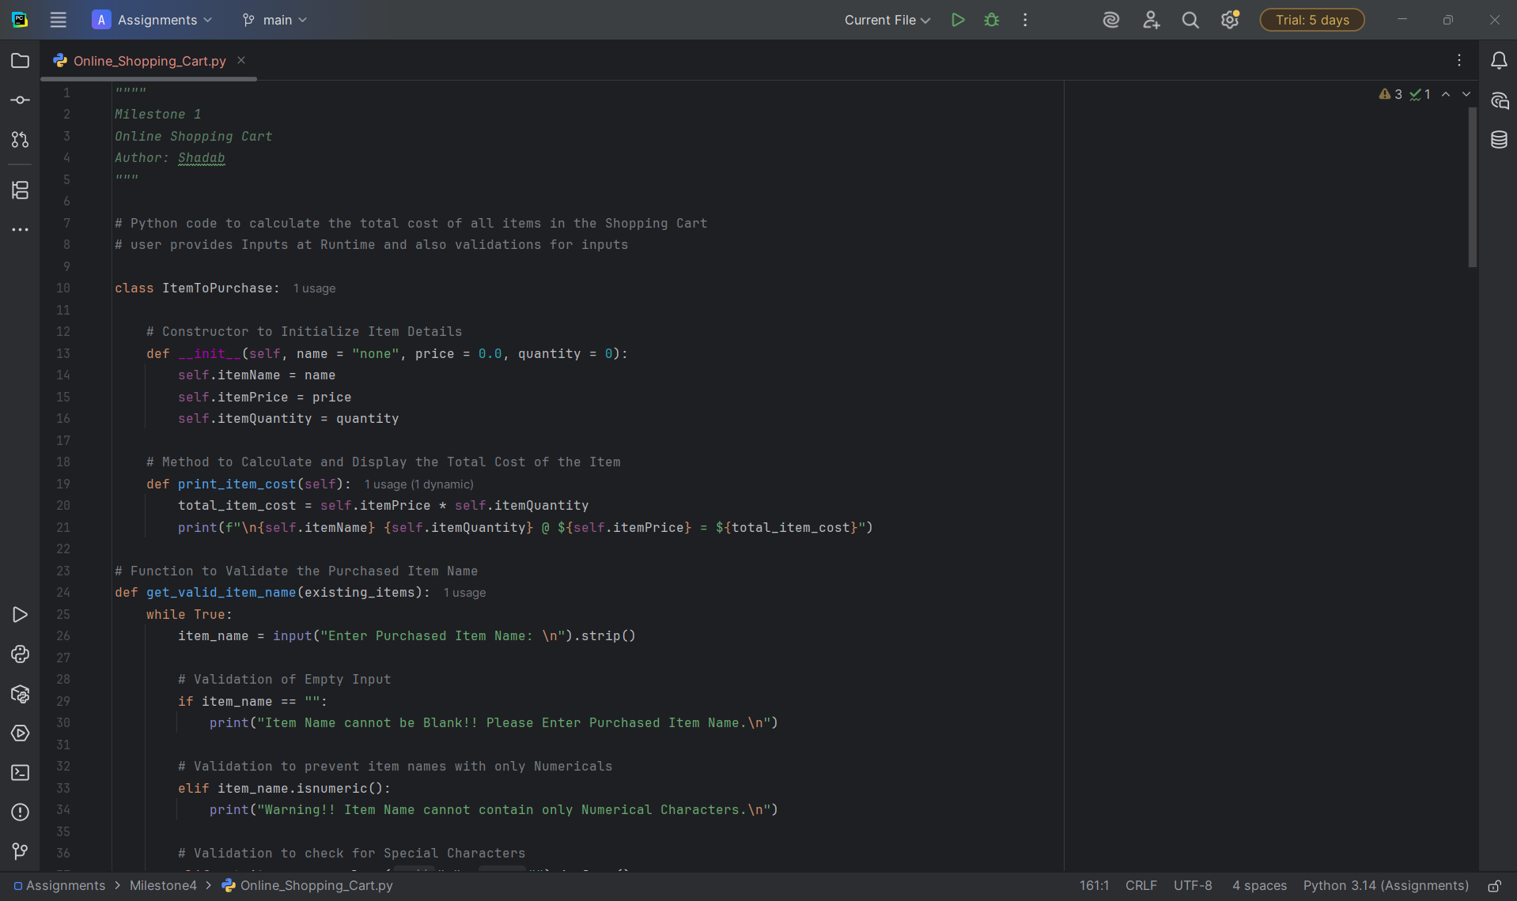

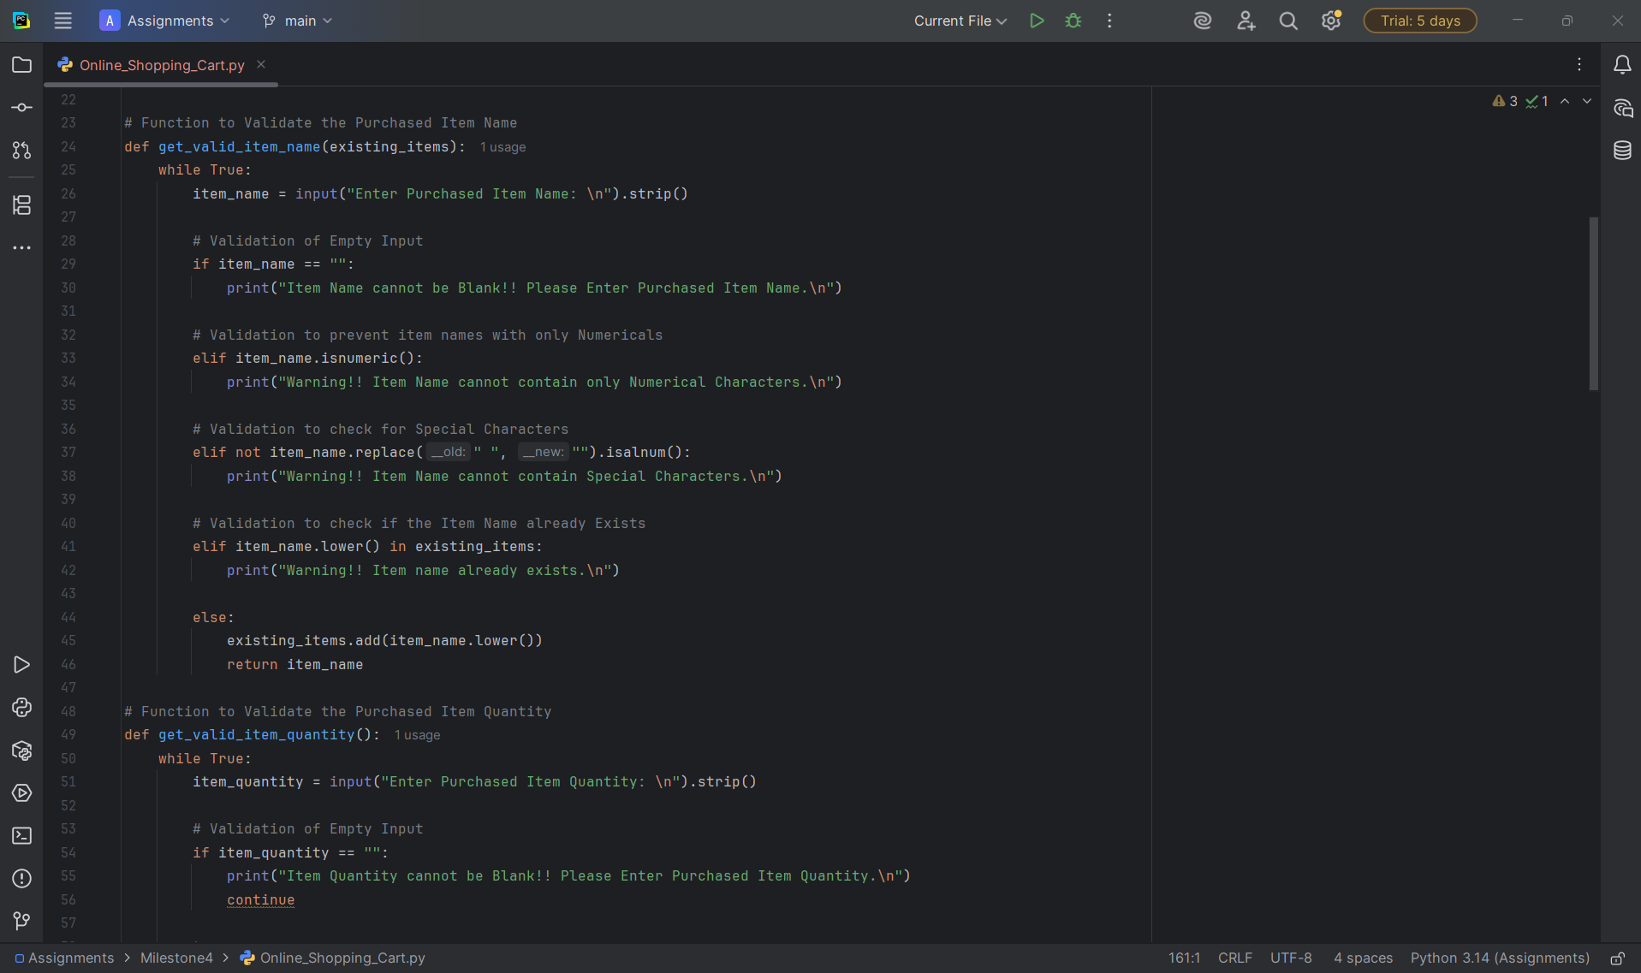

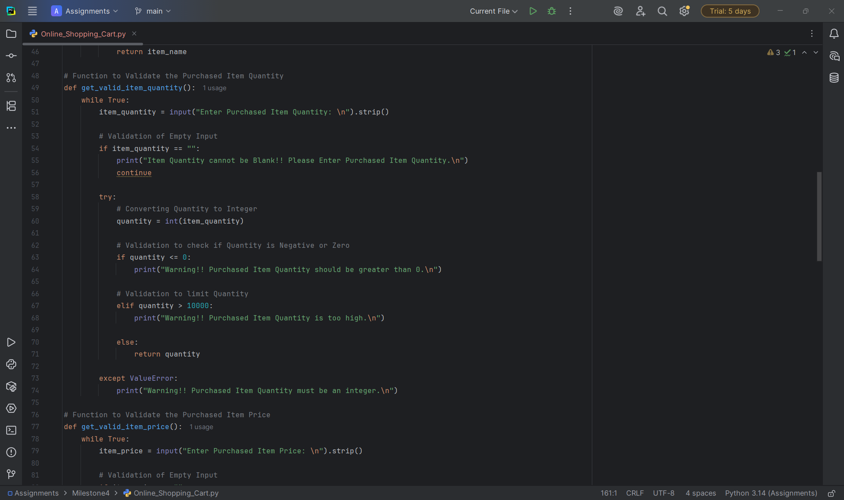

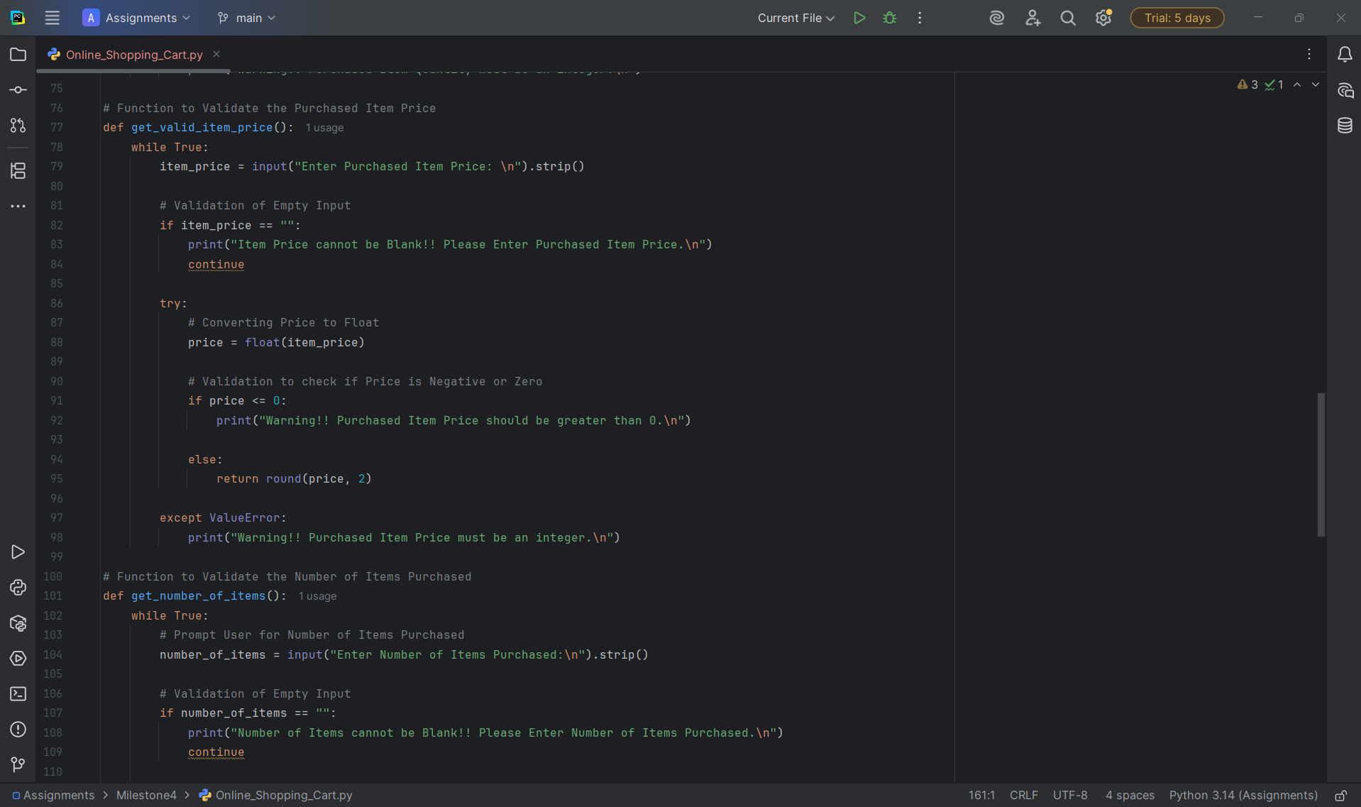

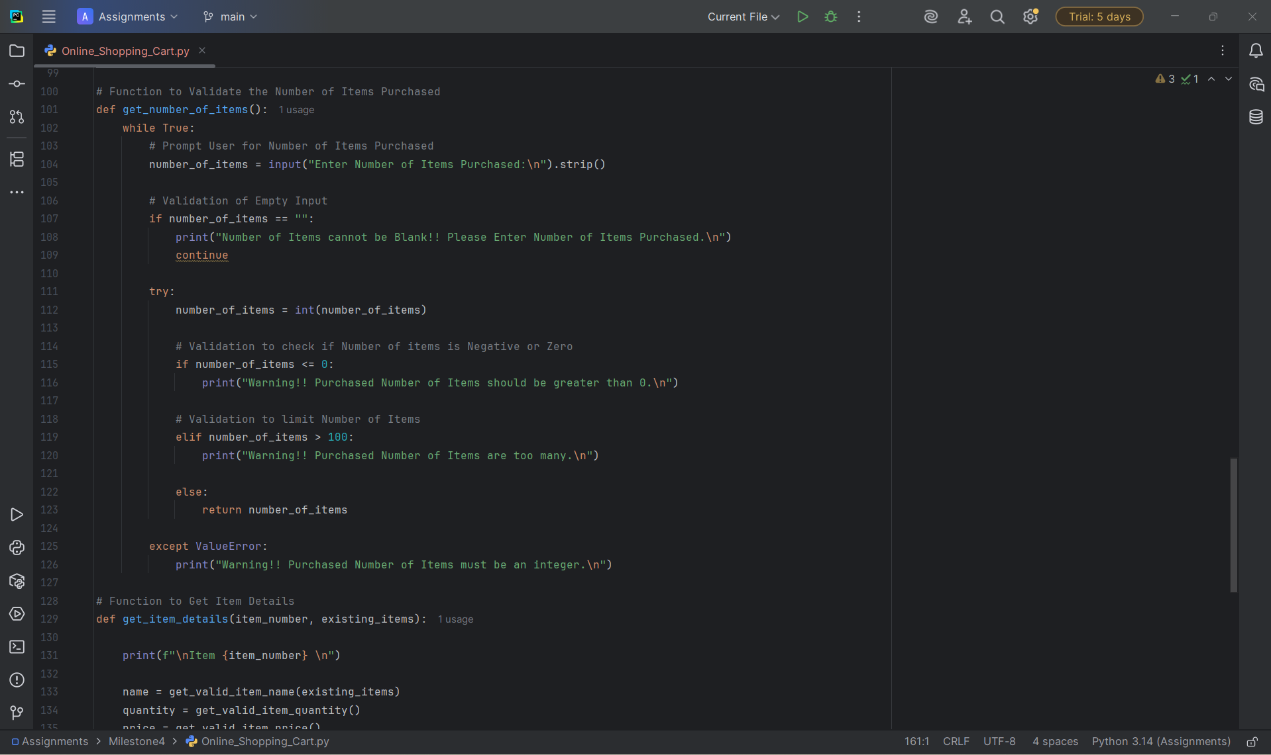

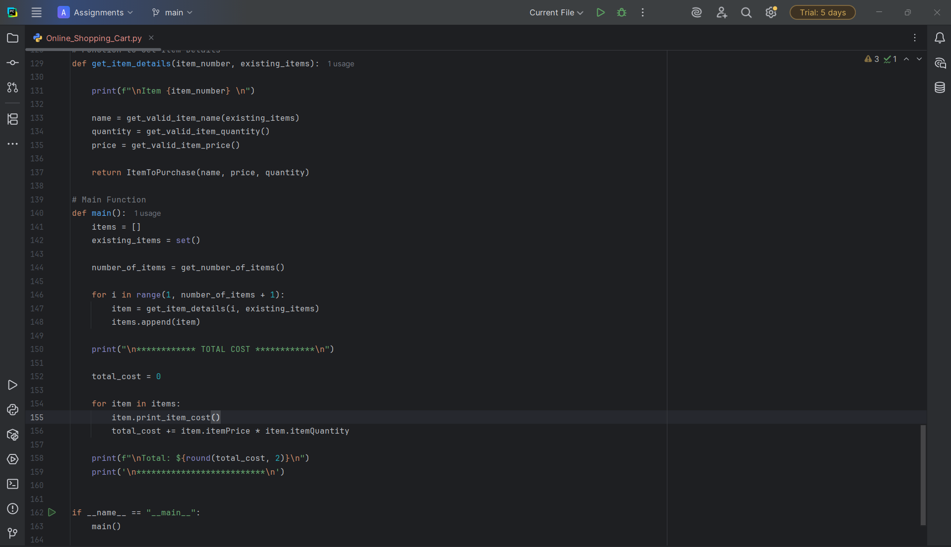

Program Execution Screenshots
Initially, User is asked to Enter Number of Items Purchased
Validations for Number of Items
Validation 1: When input is empty for number of items
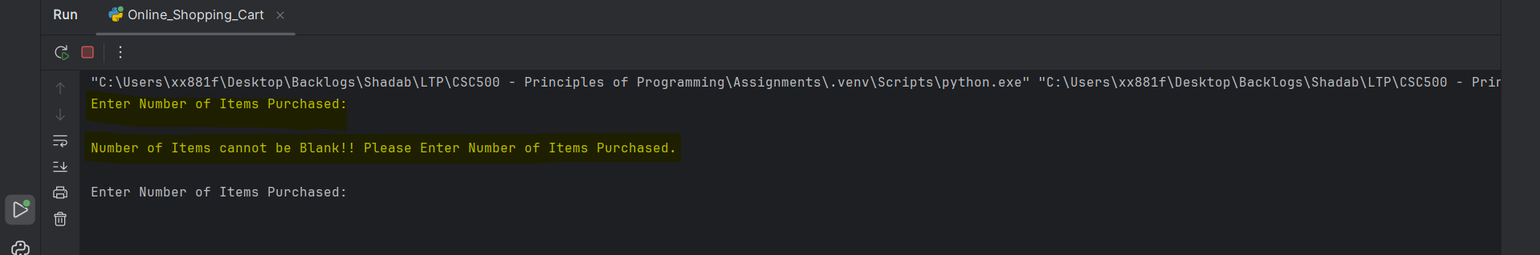

Validation 2: When input provided for number of items is strings
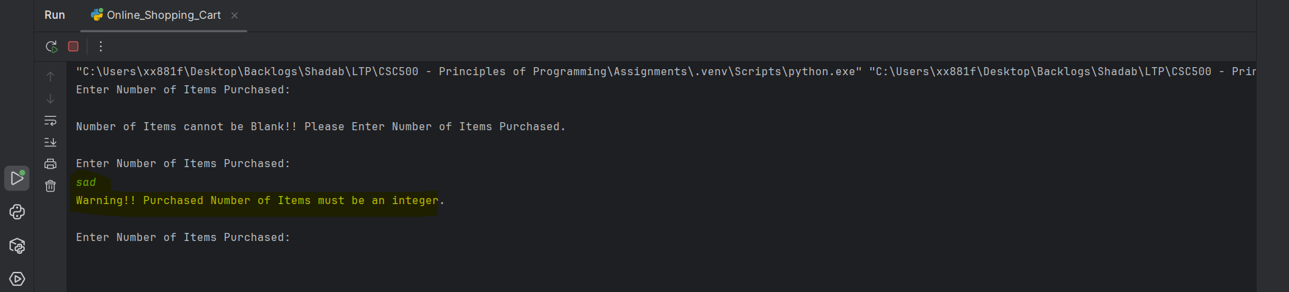

Validation 3: When number of items provided is less than or equal to zero
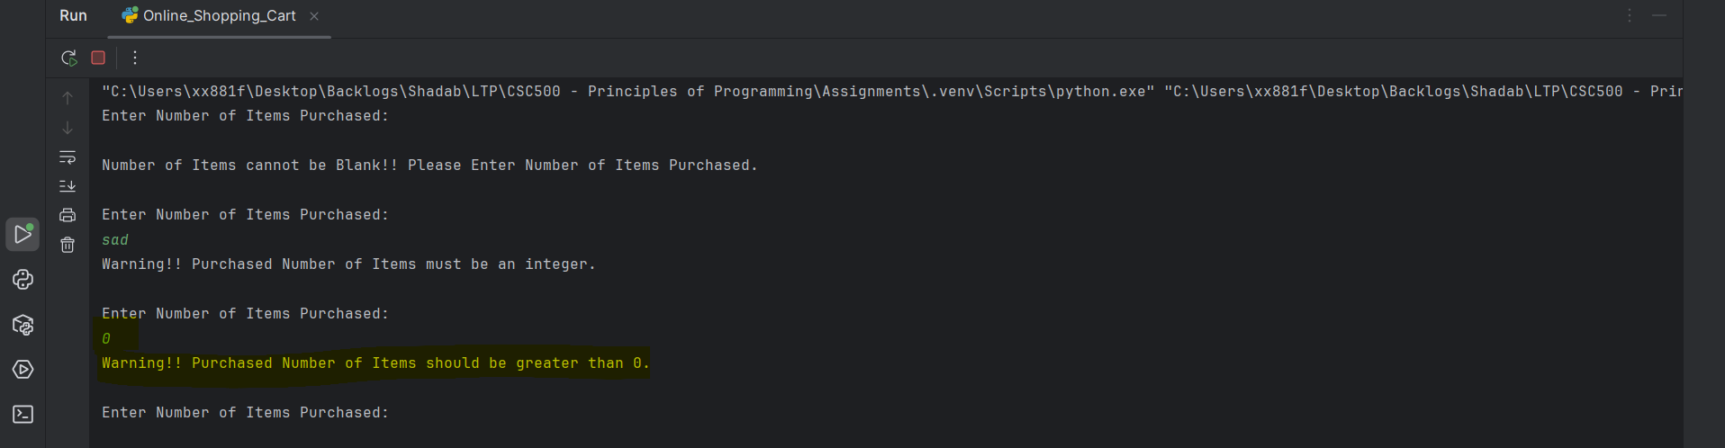

Validation 4: When number of items provided valid
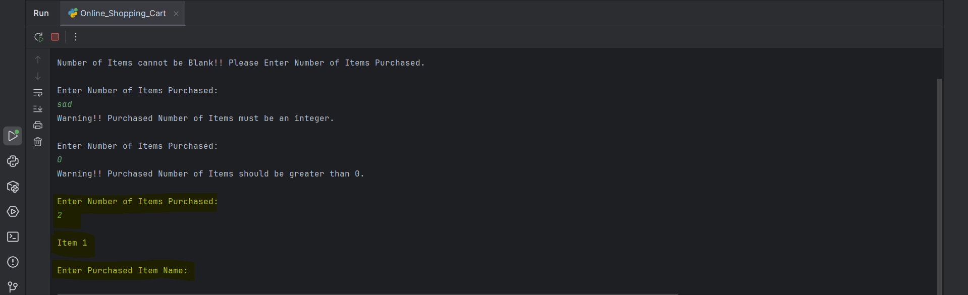

Validations for Item Name
Validation 5: When input is empty for item name
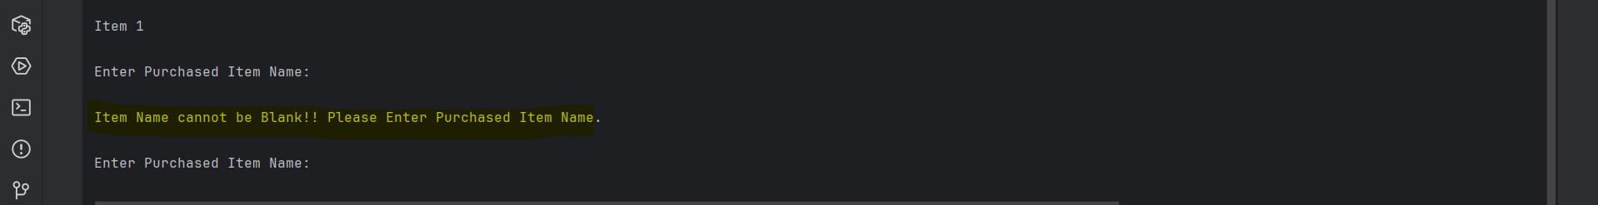

Validation 6: When input for item name contains only Numerical Characters
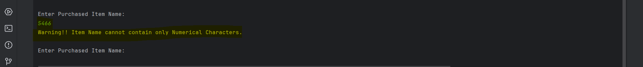

Validation 7: When input for item name contains Special Characters
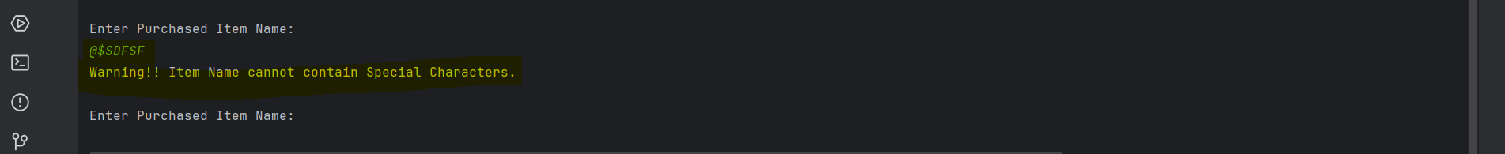

Validation 8: When input for item name is valid

Validation 9: When Duplicate Item Name is provided
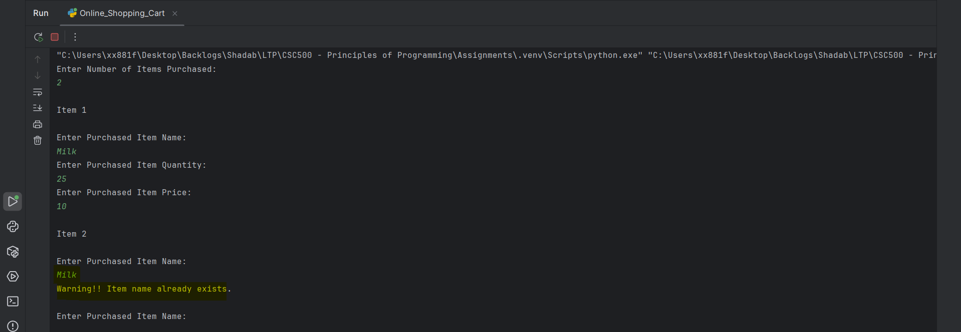
Validations Item Quantity
Validation 1: When input is empty for item quantity
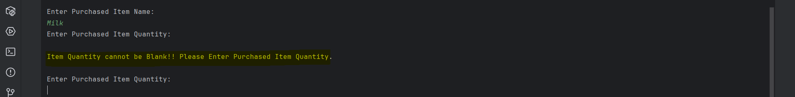

Validation 2: When input provided for item quantity is strings
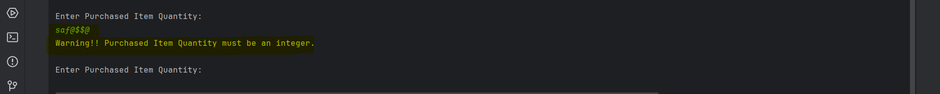

Validation 3: When item quantity provided is less than or equal to zero
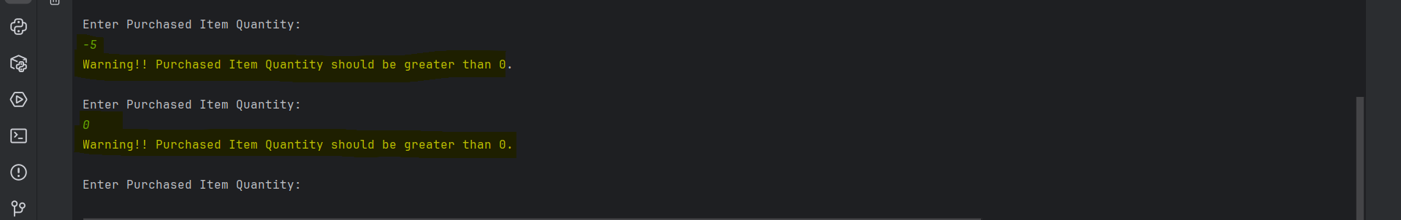

Validation 4: When item quantity provided is valid

Validations Item Price
Validation 1: When input is empty for items price

Validation 2: When input provided for item price is strings

Validation 3: When item price provided is less than or equal to zero
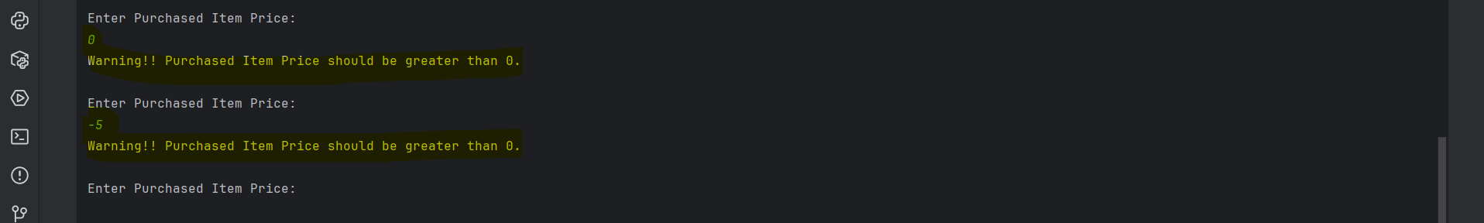

Validation 4: When item price provided is valid
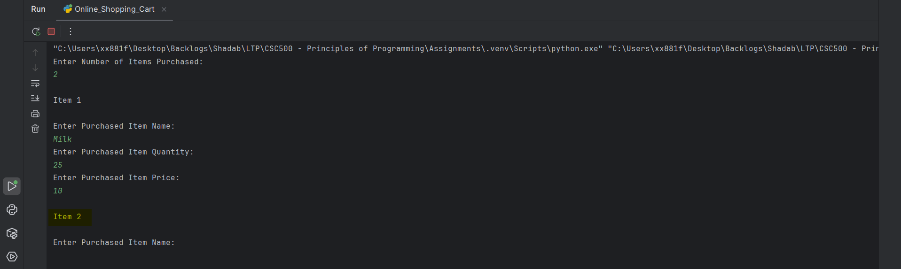

Final Result
